# Overview

This procedure is triggered by a request from FMD or FRO to create a Foreign Bond in Findur. Two Operational Assistants are required for this procedure: one to create and make sure the bond meets the criteria for a holding instrument, and the other to verify that the information entered is correct.

The same process is applied to the 2WAY CSA bond creation request for a foreign bond. If the 2WAY CSA dummy security is CAD, this will go through MDM and does not need to get sent to FRO. TASS receives an email from FINP to create a dummy security:

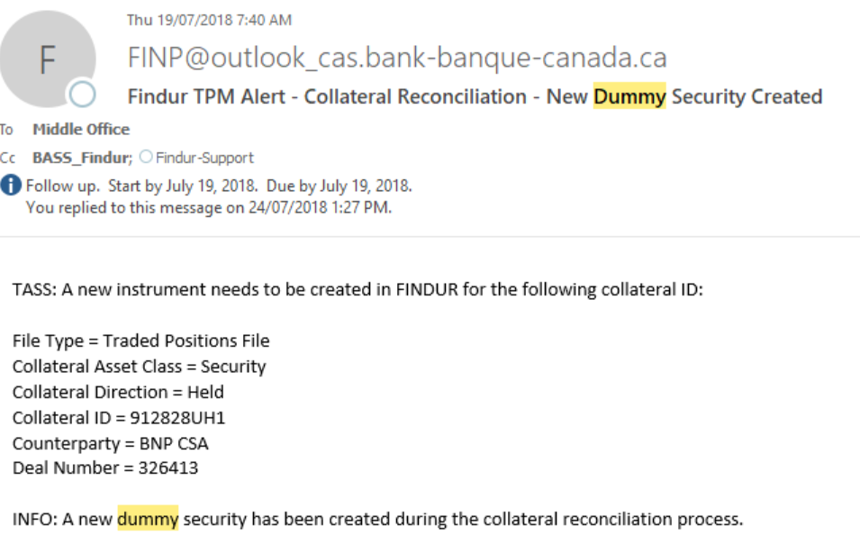15-

For creating other types of instruments, please refer to the links below:

* [Creating a New Global Bond](http://cc/sites/fbd/dm/_layouts/15/DocIdRedir.aspx?ID=BOCFBD-173-372)
* [Creating a Floating Rate Note (FRN)](http://cc/sites/fbd/dm/_layouts/15/DocIdRedir.aspx?ID=BOCFBD-173-374)
* [Creating a Fixed or Floating Medium Term Note (MTN or EMTN Program)](http://cc/sites/fbd/dm/_layouts/15/DocIdRedir.aspx?ID=BOCFBD-173-3026)
* [Creating a New BIS-MTI Instrument](http://cc/sites/fbd/dm/_layouts/15/DocIdRedir.aspx?ID=BOCFBD-173-375)

# Procedure

1. Ensure that the email from FMD or FRO has the **BBG Description** page and where it will settle (BOE, FRB, CREST).
2. On the **BBG Description** page, ensure that the instrument is not one of the following, as trading of these instruments is not permitted.

Market of Issue = PRIV PLACEMENT

Collateral Type = SUBORDINATED

Collateral Type = JUMBO PFAND BRIEF

Calc Type = MULTI-STEP BOND

US Treasury Notes = Mty/Refund Type = Callable

French OAT = Calc Type = France I/L:Street

Quarterly bonds

Index Linked

Callable Call bonds.

Calc Type (1) Odd Coupon Method  
For this type of instrument, if the instrument meets any of the following criteria, perform the associated actions.

| Criteria | Action |
| --- | --- |
| Government Guaranteed Securities - GGS instrument | Retrieve the **Prospectus** and provide it to the FRO Analyst before entering the bond in FINDUR.  The naming format for GGS legal entities should be **GGS-xxxx**, such as GGS-CBAUST. |
| Odd Coupon Method | Verify with a FRO Analyst that the following information on the **Bloomberg Security Description** matches the **Prospectus**:  Maturity date  Coupon size  Coupon Frequency  Interest Accrual Date  Coupon Dates per Bloomberg Cash Flow Schedule  Issue Amount Outstanding  Business Day conventions  Yield Basis conventions |
| Sovereign Bonds with DTC Settlement | Verify with a FRO Analyst on a case-by-case basis. |
| French Bonds with DTC Settlement | Verify with a FRO Analyst on a case-by-case basis. |

1. Save the following BBG print screens:

BBG Description page

BBG Cashflow

BBG BXT fake trade ticket with the following details:

BUY 25MM

Price 100

If the Accrued is showing “0.00” change the settlement date to a later date so that there is some accrued interest.

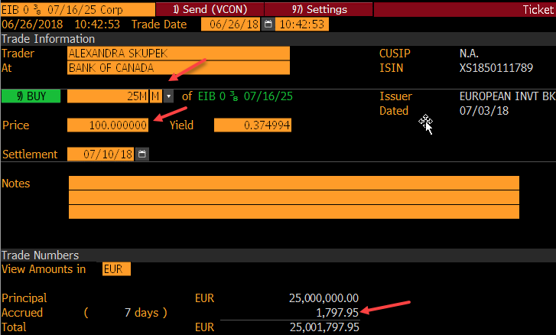

1. Open the **Issuer Document**.  
   Path: R:\scu\tass\MiddleOffice\FINDUR\Findur – ALL Foreign Bonds\Issuer_Document_TASS  
   *This document was created and maintained by FRO. You will use this document to enter/verify certain fields in the setup of the instrument.*
2. If the bond is issued by a new issuer that is not currently in the holdings, notify FRO and XFA. FRO will update the Issuer Document.
3. Open the **New Bond Template**.  
   Path: R:\scu\tass\MiddleOffice\FINDUR\Findur – ALL Foreign Bonds\New Bond TEMPLATE.
4. Use **Save As** (to not overwrite the template) to save the template as **ISIN_INS<##>_MMDDYYYY**, where **<##>** represents the instrument number after it is created and the date (**MMDDYYYY)** is the maturity of the instrument.

(ex. XS2023679843_INS131287_09062029)  
*You will use this document to add your print screens.*

1. Create the bond in Findur.
   1. From the email, identify the settlement.
   2. In the **BBG DES** page, find the currency and BBG acronym.
   3. In the **Issuer Document**, click the tab that applies to the currency, and find the BBG Acronym to determine the template.

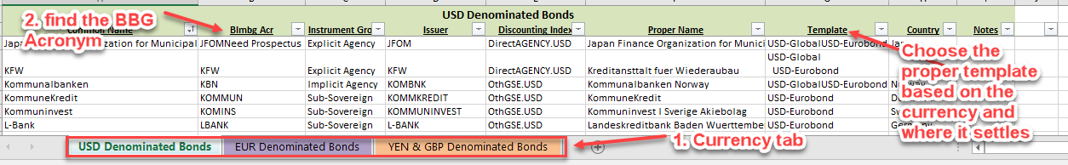

* 1. In Findur, navigate to **Securities** > **Foreign Bonds** > **BD Templates** tab.
  2. Open the appropriate bond template **twice**. Keep one window open for reference and your second window will be used to create your new bond.
  3. On the second window, click **File** > **Clear Instrument Number**.  
     *The Instrument Number is cleared, and BOND INPUT appears at the top of the window. The Operational Assistant’s LAN I.D. appears in the Trader ID field.*

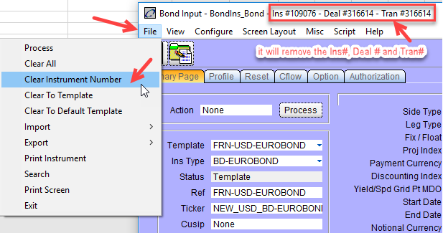01-19-2022

* 1. On the **Primary Page** tab, ensure the **Settlement Date** is consistent with the template.
  2. Enter the following information:

| Field | Information to Enter |
| --- | --- |
| Ticker | BLMBG ACR (from Bloomberg description) |
| Cusip | ALWAYS use CAPITAL letters (if there is none, leave blank) |
| ISIN | ALWAYS use CAPITAL letters |
| Book | USD Global bonds:  For BOE, holiday schedule is London-New York-Toronto  For FRB, holiday schedule is New York- Toronto  USD Eurobonds:  Holiday schedule is New York-Toronto-London  EUR Eurobonds:  For BOE, holiday schedule is London-Target-Toronto |
| Issuer | Issuer (from Issuer document).  If the legal entity’s name is not in the pick list, check with the trader to ensure that the entity is an EFA counterparty.  If the entity is an EFA counterparty, contact FRO, and they will update Findur. FRO will go into the Reference Manager > click on the entity’s name > select the Business Unit and in the Function(s) box click to insert a checkmark at Issuer.  **issuer**  If the entity is not an EFA Counterparty, advise FRM, and DO NOT PROCEED. |
| Discount Index | Index from Issuer Document |
| Start Date | Interest Accrual Date |
| End Date | Maturity Date |
| Rate | Coupon |
| Yield Basis | Verify the template, or if the value in the FINDUR Bond Profile **Payments** column does not match the **Interest** column value from the BBG Cashflow screenshot, then refer to the **Coupon** box on the **Bloomberg Security Description**:   |  |  |  | | --- | --- | --- | | Info | Calculation | Yield basis | | ISMA or SIA | ISMA 30/360 | 30/360 FIXED from pick list front page. | |  | 30/360 | 30/360 FIXED from pick list front page. | | Short or Long 1st Coupon | Short OR Long 1st Coupon | Act/Act Bond Unadjusted from pick list front page. | | Short Last Coupon | 30/360 FIXED | 30E/360 Unadjusted from pick list front page. | | SPGB  (Spanish bond) | SPGB | Act/Act Bond Unadjusted from pick list front page. | | All other bonds |  | Verify under **Fixed** line in the **Coupon** box. | |
| Payment Period | Verify under Coupon.  Keep the default for Zero Coupon bonds. |
| Front Roll Date | 1st coupon date |
| Holiday Schedule | Verify the Template (if there are any issues verify with FRO Analyst) |
|  |  |
| **A. Japan – for Japanese bonds only** | |
| Book | BOJ |
| Payment Currency | JPY |
| Discounting Index | JPGOVT.JPY |
| Yield Basis | Act/Act Bond Unadjusted |
| Holiday Schedule | Tokyo + Toronto |
| **B. Spain – for Spanish bonds** | |
| Roll Convention | No EOM |

* 1. On the **Authorization** tab, enter the following information:

| Field | Information |
| --- | --- |
| Total Issue Size | Amount Outstanding  This amount may change depending on the effect re-openings and/or buyback. |
| Instrument Group | Category (from Issuer document) |
| Yield Calc Basis and Acc.Calc Basis | Verify the template, or if the value in the FINDUR Bond Profile **Payments** and **Payments** **date** columns do not match the **Interest** column value from the BBG Cashflow screenshot, then refer to the **Coupon** box on the **Bloomberg Security Description**:   |  |  |  |  |  | | --- | --- | --- | --- | --- | | Info | Calc | Yield Calc Basis | Accrual Calc Basis | Final Coupon Yld Basis | | ISMA or SIA | ISMA 30/360 | Follow template | Follow template |  | |  | 30/360 | 30/360 from pick list back page | 30/360 from pick list back page |  | | Short OR Long 1st Coupon | Short OR Long 1st Coupon | Act/Act Bond from pick list back page | Act/Act Bond from pick list back page |  | | Euro Bond | Long 1st Coupon |  |  | Act/Act Monetary from back page | | Short Last Coupon | Short Last Coupon | 30E/360 Unadjusted from pick list back page | 30E/360 Unadjusted from pick list back page | 30E/360 Unadjusted from pick list back page | | SPGB (Spanish bond) | SPGB | Act/Act Bond from pick list front page | Act/Act Bond from pick list front page |  | |
|  |  |
| **A. Japan – for Japanese bonds only** | |
| Yield to Price Rounding | 5 |
| Instrument Group | Sovereign |
| Yield Calc Basis | Act/365 Unadjusted |
| Accrual Calc Basis | Act/365 Unadjusted |
| Accrual Rounding | 7 |
| Accrual Rounding Method | Truncate Rate Factor |
| Repo Index | SWAP.JPY |
| Final Coupon Yld Basis | Act/365 Unadjusted |
| **B. Spain – for Spanish bonds** | |
| Yield to Price Rounding | 9 |
| Final Cpn Yld to Px Rounding | 9 |
| Yield Calc Method | **True** if the end date is a non-business day (i.e., holidays, weekend).  **Standard** if the date is a regular day. |
| Final Coupon Yld Method | Normal |
| **C. Austria – for Austrian bonds** | |
| Final Coupon Yld Method | Normal |
| **D. Zero coupon – for zero coupon bonds** | |
| Accrual Calc Method | Zero Coupon Accretion |
| **E. UK GOVT BOND** | Ensure ex coupon days=7 and excoupon treatment=Business days |

* 1. If the new bond is missing information such as the coupon or maturity date, then on the **Authorization** page, under **Instrument Info**, from the **Configuration Status** list, select **Incomplete**.
  2. On the **Profile** tab, match the last payment date to the Maturity Date on the BBG DES page.
  3. Match the Payment amounts to the BBG cashflow projections.  
     If they do not match, this could be a Euroclear issue.

The Bank of Canada has an ongoing problem with coupons settling through Euroclear. The holding instruments are set up in FINDUR to match Bloomberg, but Euroclear uses a different rounding method when calculating coupon payments. Therefore, the Back Office must make manual accounting adjustments when the posting that is based on the generated Cash coupon deal does not match the actual cash amount paid out by Euroclear. If Euroclear uses the rounding formula, and it is not updated in Findur, you must add it in.  
  
To add the Payment Formula:

* + 1. While on the **Profile** tab, on the header click **View** > **Payment Formula**.
    2. Enter the formula **rate = round(rate/2,5) * 2;**
    3. Or **payment = notional * round((rate + spread) * dcf, 5) * mult;**

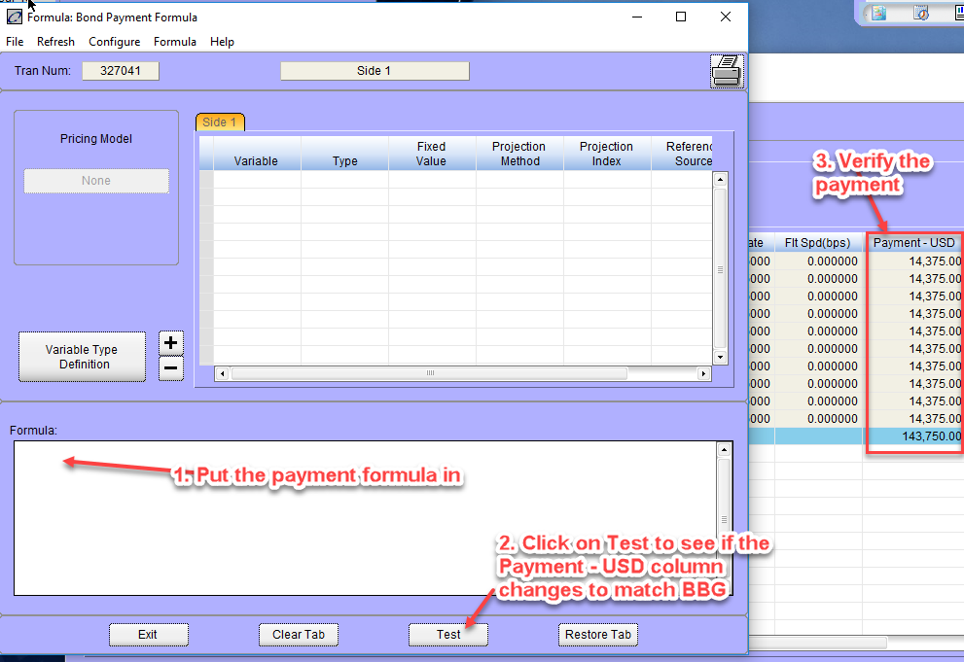

* 1. On the **Primary Page** tab, change the **Action** to **to Validated**.
  2. Click **Process**.  
     *A new Instrument Number will be created.*

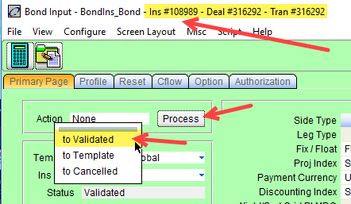

1. Validate a fake BXT in Findur.
   1. In Findur, navigate to **Securities** > **Foreign Bonds** > **RMU**.  
      *After validating the instrument, it will appear at the bottom of the RMU page.*
   2. Enter the **Trade Date**, **Settle Date**, **Par Amount**, **Buy**, and **Price**.
   3. Verify thatthe **Trade Yield** (this must match the BBG DES to the third decimal), **Accrued Interest**, and the **Proceeds** match the BXT.



If the **Accrued Interest** or **Proceeds** values do not match, trading of the new bond cannot occur. Contact the BASS-FINDUR team.

If the **Trade Yield** value is incorrect, the Back-Office’s **Year End Yield Report**, which is provided to the Auditor General and is published as **Note 5** of the **Official International Reserves Report**, will also be incorrect. The **Trade Yield** must agree to the third decimal because the yields in the report are displayed to the second decimal.

1. Update your spreadsheet from step 3.
   1. On the **Bloomberg** tab, enter the following information:

* Created By: your initials
* Authorized By: leave blank as the second OA will enter their initials
* Settlement: The Book (ie. BOE, FRB, CREST. This is on the template of the security, if it is something different than the template FRM will notify)
* Instrument #:
* Comments:
  1. Save the screenshots of the following pages on the “Bloomberg” tab: **DES**, **Cashflow**, **BXT**.
  2. On the **Template** tab, print the Findur bond template’s **Primary Page** tab and **Authorization** tab.
  3. On the **Findur Instrument** tab, print screens of the following:

**Primary Page** tab

**Authorization** tab

**Profile** tab

RMU trade ticket

1. Have a second OA verify the New Instrument in Findur and the spreadsheet.
2. Reply All to the email from FRM, and add [FRO-Reporting@bank-banque-canada.ca](mailto:FRO-Reporting@bank-banque-canada.ca), and include the Instrument Number and the Bloomberg’s DES page if not provided already by FRM.